Software Requirements Specifications (SRS)
Project: Smart Parking Application Development
Version: 7.0
Date 10.29.2026

Overview:
This project was acquired through our mutual associates at Ħardware ¢orp who have worked with us in the past and recommended us to the investors. We at $oftware ¢orp have a positive working history with Ħardware ¢orp and their products and look forward to helping their customers.
$oftware ¢orp is dedicated to delivering quality software platforms to streamline solutions for investors. We have been in business since 2005, working in various industries from rare-metal mining to hotel management.
For this project, we plan to design a smart parking application that will make it easy for drivers to locate, reserve, and pay for parking while also helping operators manage their parking spaces. Our main objective is to program software that can accomplish this and deliver it to the investors.

- Introduction
  - Background
The current smart parking industry focuses on providing drivers with a simple and accessible way to find, reserve, and pay for parking from most smart devices. It also provides a way for parking managers to monitor their parking spaces. Some applications contain unique features such as enforcement or advanced reservations. What makes our app unique is parking information Most apps show where parking is available, but they don’t mention what kind of parking is available. Our application will include a field to define the safety, quality, and security of a parking garage by including metrics like lighting, EV charging, camera coverage, and distance from surrounding establishments. This will allow drivers to select parking that fits their needs and is a place they can feel comfortable leaving their vehicle.
  - Purpose
This document defines the requirements for the Smart Parking Application Development.
  - Scope
This Smart Parking System will be designed to provide a mobile application that facilitates locating and acquiring parking spaces for drivers while also helping parking operators manage their parking. This application will help users view, reserve, and pay for parking through a web based or mobile application. It will include features such as live parking availability, digital payment processing, parking reservation receipts, notifications, parking safety ratings, parking comparison, and integration with external navigation services. The application will also help parking operators by including an administrative dashboard with occupancy reporting and analytics. The live parking availability will be monitored by entry/exit sensors along with QR codes that confirm occupancy and send that information to the system.

The goal of this project is to develop the software aspect of this application, excluding hardware applications. Additionally, this project does not include support for any enforcement features, EV charging integration, or autonomous vehicle integration. While we will be integrating with hardware, we are not designing the hardware.

- Overall Description
2.1 Users
The main users will be the drivers or vehicle owners and the parking operators.
2.2 System Environment
The application will be developed for both a web-based and mobile platforms. The web-based option will be available on Chrome, Mozilla Firefox, Microsoft Edge, and Safari. The mobile option will be available in the play store on both Android 11+ and IOS 17+
2.3 Constraints
The application must be developed on a fixed semester timeline, it will need to depend on third-party services and APIs, it will have to follow city ordinances and laws, and it will need to fulfill security and privacy requirements. Budget will not be an issue.
2.4 Assumptions
For this application to provide live parking updates, it will need internet access. It will also need parking operators to input the parking information themselves. The parking operators will also have to equip their garages with approved entry/exit sensors along with QR code scanners at the gates to send occupancy data to the system.

- Functional Requirements
FR1: Register users and authenticate them with 2 factor authentication
FR2: Allow users to log in once they have registered
FR3: Display available parking on an interactive map
FR4: Update available parking data live based on unreserved parking spaces and reserved parking spaces
FR5: Provide a way to reserve one or more parking spaces
FR6: Able to perform digital transactions to pay for parking
FR7: Allow users to view the location of their selected parking space
FR8: Integrate with navigation services to guide drivers to their parking space
FR9: Display history of previous parking reservations with receipts
FR10: Opens to administrative dashboard for parking operators
FR11: Administrative dashboard includes basic analytics for the parking operator
FR12: Occupancy reports and analytics will be generated for parking operators
FR13: Will be able to send notifications to users for any alerts
FR14: Show available parking nearby or based on inputted location
FR15: Allow users to cancel their parking reservations
FR16: Calculate parking fees based on operator’s set price and duration
FR17: Operators can add, remove, or disable spaces
FR18: Operators can input parking rates for spaces
FR19: Operators can input information on safety and accessories of a parking space
FR20: Allow users to view parking spot details, including safety, cost, availability, etc
FR21: Generate QR code for reservations to be scanned at garage entry gate to begin and end their parking time
FR22: Integrate with entry/exit garage sensors to count occupancy
FR23: System will include a manual override for occupancy counting in case of errors or discrepancies
FR24: The system will record vehicle entry and exit data along with reservations

- Non-Functional Requirements
NFR1: This system will support 3,000 concurrent users
NFR2: This system will be able to store up to 150,000 users
NFR3: Updates parking data live every 5 seconds
NFR4: System will provide 99.9% uptime
NFR5: Users log in information will be encrypted
NFR6: Web-based option will be available on Chrome, Mozilla Firefox, and Microsoft Edge
NFR7: Mobile option will be available on Android 11+ and IOS 17+ play stores
NFR8: Will report time down to minutes
NFR9: Will report money values down to cents
NFR10: All data will be backed up to separate cloud servers in case of server issues
NFR11: System can be expanded if needed
NFR12: Will follow accessibility requirements
NFR13: Cybersecurity measures will be implemented to protect user data
NFR14: System stores occupancy data from sensors and QR code scans
NFR15: Entry gate integrates with user reservation QR code for entry

- Use Cases

1.
Title: Register New User
Actor: New User
Precondition: User has a access to the application through a compatible device or web browser
Steps:
- User selects option to make a new account
- User enters the required profile information
- User selects whether they are registering as a driver or parking operator
- User selects available verification method, such as email or phone number
- System sends a verification code using the selected method
- User enters verification code
- System verifies the code and completes account registration
- User is signed in and directed to the appropriate home screen
Postcondition: User is registered in the system and can return by logging in with their account information

2.
Title: Returning User Login
Actor: Registered User
Precondition: User has a registered account
Steps:
- User selects the option to sign in
- User provides their account credentials
- System validates the provided credentials
- If the credentials are valid, the system will sign the user in
- User is directed to the home screen based on user account type
Postcondition: User is signed into their account and can begin accessing the features available to their account

3.
Title: Register Vehicle
Actor: Registered User (Driver)
Precondition: User is registered as a driver and is signed into the application
Steps:
- User accesses the vehicle management area
- User selects the option to add a vehicle
- User enters the required vehicle information
- User submits the vehicle information
- System saves the vehicle to the user’s account
Postcondition: The vehicle is registered to the user's account and can be selected for future parking reservations

4.
Title: Parking Space Reservation
Actor: Registered User (Driver)
Precondition: User has a registered account and at least one registered vehicle
Steps:
- User access parking reservation area
- User inputs desired parking location, date, and time (including ASAP)
- System searches for participating parking garages near the provided location and displays parking options based on current availability
- User selects a parking garage
- System displays relevant garage information, including availability, location, safety details, parking rates, and other important reservation details
- User selects desired parking option and continues with reservation
- User selects the registered vehicle associated with the reservation
- System displays reservation details, including selected garage, reservation period, and final cost
- User reviews and confirms the reservation details
- System verifies that the parking option is still available
- User inputs payment information and authorizes the payment
- System processes the payment
- If payment is successful, a reservation will be created and the garage’s available parking inventory will be updated
- System provides the user with a confirmation of the completed reservation
Postcondition: User has a confirmed, paid for parking reservation associated with the selected vehicle, and the system updates the parking inventory accordingly.

5.
Title: Review Reservation
Actor: Registered User (Driver)
Precondition: A user has a registered account and has made at least one reservation
Steps:
- User accesses the reservation management area
- System displays the user’s current and previous reservations
- User selects a reservation
- System displays the details associated with the selected reservation
Postcondition: User can view the details of current and previous parking reservations

6.
Title: Reservation Cancellation
Actor: Registered User (Driver)
Precondition: A user with a registered account and a future reservation
Steps:
- User accesses the reservation management area
- System displays the user’s current and previous reservations
- User selects the reservation they would like to cancel
- System displays the details associated with the selected reservation
- User selects the cancellation option
- System returns confirmation for cancellation
- User confirms cancellation
- System approves cancellation and the garage’s available parking inventory will be updated accordingly
- System refunds the reservation
Postcondition: User cancels their reservation, the system approves the cancellation, updates garage inventory, and refunds the reservation

7.
Title: Parking Spot Navigation
Actor: Registered User (Driver)
Precondition: A user with a registered account and a valid reservation
Steps:
- User accesses the reservation management area
- System displays the user’s current and previous reservations
- User selects a reservation they would like to navigate to
- System displays the details associated with the selected reservation
- User selects the navigation option
- System sends the user to their desired navigation application with the address already input
Postcondition: User is provided directions to their parking garage

8.
Title: Add Garage
Actor: Registered User (Parking Operator)
Precondition: The user wants to post a garage listing for approval
Steps:
- User accesses the parking garage management area
- User selects option to add a new parking garage
- User uploads required documentation and details
- User reviews and confirms new parking garage listing
- Listing gains a “Pending Validation” status
- System sends the post to an operator to approve it
Postcondition: User submits a garage listing to the system for approval by an operator

9.
Title: Deactivate Parking Garage
Actor: Registered User (Parking Operator)
Precondition: User has a registered account and has made at least one parking garage listing
Steps:
- User accesses the parking garage management area
- System displays active and inactive parking garages
- User selects parking garage they would like to deactivate
- System displays selected parking garage details
- User selects the deactivate option
- System returns deactivation confirmation
- User confirms the deactivation
- System confirms the deactivation of the parking garage and prevents future reservations from being made, existing reservations must be upheld or refunded
Postcondition: Parking operator deactivates a parking garage, the system confirms deactivation, and removes the parking garage listing

10.
Title: View Parking Garages
Actor: Registered User (Parking Operator)
Precondition: User has a registered account and has made at least on parking garage listing
Steps:
- User accesses the parking garage management area
- System displays active and inactive parking garages
- User selects a parking garage
- System displays the details for the selected parking garage
Postcondition: User can view the details of their parking garage listings, active or inactive

11.
Title: Edit Parking Garage
Actor: Registered User (Parking Operator)
Precondition: User has a registered account and has made at least one parking garage listing
Steps:
- User accesses the parking garage management area
- System displays active and inactive parking garages
- User selects the parking garage to edit
- System displays the details for the selected parking garage
- User selects the editing option
- System opens fields to be edited
- User inputs new information and selects the save option
- System updates the garage listing with the new information
Postcondition: User edits the parking garage details and the system updates the garage listing with the new information

12.
Title: Analytics for All Garages
Actor: Registered User (Parking Operator)
Precondition: User has registered account and has made at least one parking garage listing
Steps:
- User accesses the analytics area
- System retrieves analytic data at the time of access and displays reports
- User can view generated reports based on all active parking garages
Postcondition: User views analytic reports for all garages and system generates reports

13.
Title: Analytics for Singular Parking Garage
Actor: Registered User (Parking Operator)
Precondition: User has a registered account and has made at least one parking garage
Steps:
- User opens the analytics area
- User selects specific parking garage to be viewed from the filter control option
- The system retrieves analytic data on the selected parking garage and displays reports
- User can view generated reports on a singular parking garage
Postcondition: User views analytic reports on specific parking garage and system generates reports based on a specific parking garage

14.
Title: Remove Registered Vehicle
Actor: Registered User (Driver)
Precondition: User has a registered account and has registered at least one vehicle
Steps:
- User access the vehicle details area
- System displays registered vehicles
- User selects the registered vehicle they would like to remove
- The system displays the details of the selected vehicle
- User selects the remove option
- System asks for confirmation of vehicle removal
- User confirms the removal of the selected vehicle
- System removes the registered vehicle from the user’s account
Postcondition: User removes a registered vehicle from their account

15.
Title: Favorite Parking Garage
Actor: Registered User (Driver)
Precondition: User has a registered account
Steps:
- User access parking reservation area
- User inputs desired parking location, date, and time (including ASAP)
- System searches for participating parking garages near the provided location and displays parking options based on current availability
- User selects a parking garage
- System displays relevant garage information, including availability, location, safety details, parking rates, and other important reservation details
- User selects the favorite option in the details page
- System saves the parking garage in the favorites area
Postcondition: User saves a parking garage under “Favorites” to be viewed later

16.
Title: Compare Favorite Parking Garages
Actor: Registered User (Driver)
Precondition: User has a registered account and more than one Favorite parking garage
Steps:
- User accesses the Favorite parking garage area
- System displays all parking garages saved to the favorites area
- User can view all favorited parking garages at the same time along with all their details and compare
Postcondition: User compares favorited parking garages and their details

17.
Title: Validate Garage Entry
Actor: Registered User (Driver)
Precondition: User has a registered account and made a reservation
Steps:
- Driver arrives at garage entrance
- Driver presents reservation QR code to the scanner
- The system checks if there is a reservation corresponding to that QR code
- If the reservation is valid, the system allows the gate to open
- If the reservation is invalid, the gate is not open
Postcondition: User is able to enter garage using their reservation and system validates reservation details and allows or denies the vehicle entry into the garage

18.
Title: Record Vehicle Entry
Actor: Registered User (Driver)
Precondition: User has entered a garage using their reservation QR code
Steps:
- Driver enters gate into garage
- Sensor triggers if the vehicle actually enters the garage and sends the data to the system
- System updates garage occupancy to reflect new vehicle entering
Postcondition: System receives live updates on garage occupancy

19.
Title: Validate Garage Exit
Actor: Registered User (Driver)
Precondition: User is leaving the parking garage within their allotted time
Steps:
- User drives up to the exit gate
- User scans reservation QR code again
- System checks if they are within their allotted time
- If they have not overstayed their reservation, the gate opens and the driver may leave
- If they have overstayed, the driver must pay a fee before the gate opens within the app
Postcondition: User can leave garage and settles fees on exit

20.
Title: Record Vehicle Exit
Actor: Registered User (Driver)
Precondition: User is exiting a garage using their reservation QR code
Steps:
- Driver exits gate to leave garage
- Sensor triggers if the vehicle actually exits the garage and sends the data to the system
- System updates garage occupancy to reflect vehicle exiting
Postcondition: System receives live updates on garage occupancy

21.
Title: Verify Garage Posting
Actor: Administrator
Precondition: A garage posting is “Pending Validation” and needs approval to go live
Steps:
- System sends garage listings pending validation to administrator
- Administrator approves or rejects the garage listing
- System posts the garage listing live and notifies the operator
Postcondition: Administrator approves garage listing and the system posts it online

22.
Title: Modify Future Parking Reservation
Actor: Registered User (Driver)
Precondition: Registered user would like to change the details of a future reservation
Steps:
- User accesses the reservation management area.
- User selects a future reservation.
- User selects the option to modify the reservation.
- User changes the desired date, time, duration, or registered vehicle.
- System checks whether the requested changes are available.
- System recalculates the reservation cost, if applicable.
- System displays the updated reservation details and any price difference.
- User confirms the changes.
- System updates the reservation and payment, if needed.
- System sends confirmation of the modified reservation.
Postcondition: The future reservation is updated with the new details and the system reflects any changes to availability and payment.

23.
Title: Extend Current Parking Reservation
Actor: Registered User (Driver)
Precondition: Registered user would like to extend the time of a reservation after entering the garage
Steps:
- User accesses the reservation management area.
- User selects a current reservation.
- User selects the option to extend the reservation.
- User changes the exit time as desired
- System checks whether the requested changes are available.
- System recalculates the reservation cost.
- System displays the updated reservation details and the additional cost.
- User confirms the changes.
- System updates the reservation and payment
- System sends confirmation of the modified reservation.
Postcondition: The reservation is updated with the new end time and the system reflects any changes to availability and payment.

24.
Title: System Handles No-Show Reservations
Actor: System
Precondition: A driver never checks into the garage for their reservation and their end time passes without them ever entering the garage
Steps:
- System monitors future reservations
- A reservation reaches its end time
- System checks for a record of a confirmed vehicle entry
- If not entry is found, the system marks the reservation as No-show/expired
- System returns the parking space to the inventory
- System invalidates the QR code for the reservation
- System still charges user for the space
Postcondition: No-show reservations are processed and don’t lead to spaces being left outside of the inventory

25.
Title: View Garage Reservations
Actor: Registered User (Operator)
Precondition: The operator wants to monitor their garage reservations
Steps:
- Operator accesses garage management area
- Operator selects a garage
- Operator opens the reservation management area
- System displays current and upcoming reservations for that garage
- Operator can filter by day, time, no-show, upcoming, past, etc.
- Operator selects a reservation to view details
- System displays permitted reservation details
Postcondition: Operator can view parking reservations for their parking garage

26.
Title: Manual Occupancy Recording
Actor: Registered User (Operator)
Precondition: The operator needs to input the occupancy data manually
- Operator accesses the garage monitoring area.
- System displays the current recorded occupancy.
- Operator selects the occupancy correction option.
- Operator enters the verified current vehicle count.
- Operator provides a reason for the correction, such as sensor failure or manual count.
- System asks for confirmation.
- Operator confirms the correction.
- System updates the garage occupancy and available-space count.
- System records the previous value, corrected value, timestamp, operator, and reason in an audit log.
Postcondition: Operator can input occupancy data in the event the automatic system is not working

27.
Title: Send System Notification
Actor: System
Precondition: An event in the system occurs and triggers a notification
- A qualifying system event occurs or a status changes
- The system identifies the notification tied to the event
- The system determines the appropriate recipient
- The system generates an appropriate response
- The system sends the notification via the users preferred method
- The system records the notification was sent
Postcondition: The user is notified of an important event by the system

28.
Title: Review Payment History
Actor: Registered User (Driver)
Precondition: The user wants to view their payment history
- The user accesses the reservation management area
- User selects reservation
- System displays reservation details and payment details
- User can select an option to view full receipt
Postcondition: User is able to retrieve payment information from previous reservations

29.
Title: Filter Garage Analytics
Actor: Registered User (Operator)
Precondition: The operator wants to filter the displayed garage analytics
- User accesses the analytics area
- User inputs desired filters
- System retrieves analytic data based on filter controls
Postcondition: User can view analytics based on desired filters and the system retrieves the desired data

30.
Title: Select Report Type for Analytics
Actor: Registered User (Operator)
Precondition: The operator wants to change the type of report produced by the system
- The user accesses the analytics area
- The user selects the type of report they would like from the available list in the drop down option
- The system reorders the data into the desired report type
Postcondition: User can change the type of report produced by the system

31.
Title: Password Reset
Actor: Registered User
Precondition: User has a registered account and access to the email address or phone number associated with the account.
Steps:
  - User selects the “Forgot Password” option from the login screen.
  - Users enters the email address or phone number associated with their account.
  - System verifies that the account exists.
  - System sends a password reset link or verification code to the user’s registered email address or phone number.
  - User opens the reset link or enters the verification code.
  - System verifies the reset request.
  - User enters and confirms a new password.
  - System validates that the new password meets security requirements.
  - System updates the account password.
  - System confirms the password reset and directs the user back to the login screen.
Postcondition: User successfully resets their password and can log in using the new password.

6. Work Breakdown Structure

WBS | Task Name | Duration | Start | Finish | Predecessors
0 | CIS4374 wbs | 77 days? | Wed 1/20/27 | Thu 5/6/27
1 | Back-End Development | 33 days? | Wed 1/20/27 | Fri 3/5/27
1.1 | Authentication | 8 days? | Wed 1/20/27 | Fri 1/29/27
1.1.1 | Account registration logic
1.1.2 | Login/log out logic
1.1.3 | Email verification service
1.1.4 | Phone number verification service
1.1.5 | Car verification service
1.1.6 | Garage verification service
1.1.7 | Operator verification pathway
1.1.8 | Password reset logic
1.2 | User/Operator Setup | 10 days? | Mon 1/25/27 | Fri 2/5/27
1.2.1 | Operator account management |  |  |  | 3
1.2.2 | Driver account management |  |  |  | 12
1.2.3 | Vehicle registration form |  |  |  | 7
1.2.4 | Garage registration form |  |  |  | 8
1.2.5 | Role selection option
1.2.6 | Garage management logic |  |  |  | 8
1.2.7 | Garage ownership approval process
1.3 | Garage Monitoring | 15 days? | Mon 2/1/27 | Fri 2/19/27
1.3.1 | Garage search function |  |  |  | 17
1.3.2 | Garage location on map function |  |  |  | 17
1.3.3 | Navigation function and API
1.3.4 | Garage details display logic |  |  |  | 17
1.3.5 | Live parking availability logic
1.3.6 | Live parking status updates |  |  |  | 24
1.3.7 | Parking reservation logic |  |  |  | 24,136
1.3.8 | Operator reservation management logic
1.3.9 | Duplicate reservation prevention
1.3.10 | Double booked parking space prevention
1.3.11 | Reservation cancellation logic
1.3.12 | Align parking availability with reservations
1.3.13 | Garage occupancy function
1.3.14 | Operator garage management function
1.3.15 | Driver reservation management
1.3.16 | Entry Reservation Validation
1.3.17 | Reservation status synchronization
1.3.18 | Entry/Exit event processing
1.3.19 | Exit Reservation Validation
1.3.20 | Future reservation modification logic
1.3.21 | Current reservation extension logic
1.3.22 | Operator reservation management service
1.3.23 | No show reservation expiration processing
1.3.24 | QR code generation
1.3.25 | Manual occupancy adjustment processing
1.3.26 | Occupancy audit logging
1.3.27 | Driver reserved space confirmation
1.4 | Payment | 12 days? | Mon 2/8/27 | Tue 2/23/27
1.4.1 | Payment screen logic
1.4.2 | Link between reservation and payment |  |  |  | 26
1.4.3 | Exit payment validation
1.4.4 | Overstay fee calculation
1.4.5 | Parking fee calculation
1.4.6 | Payment API service
1.4.7 | Validate transactions
1.4.8 | Transaction history logic
1.4.9 | Refund processing
1.5 | Reporting | 8 days? | Wed 2/24/27 | Fri 3/5/27 | 19,47
1.5.1 | Notification trigger processing
1.5.2 | Notification delivery service
1.5.3 | Collect previous and current parking reservations
1.5.4 | Generate parking reservation report |  |  |  | 26
1.5.5 | Occupancy data retrieval
1.5.6 | Revenue data retrieval
1.5.7 | Reservation data retrieval
1.5.8 | Generate report logic
1.5.9 | Filter control logic
1.5.10 | Export report logic
1.5.11 | Driver dashboard
1.5.12 | Operator dashboard
1.5.13 | Integrated reports into dashboard
2 | Database Development | 33 days? | Wed 1/27/27 | Fri 3/12/27
2.1 | Authentication | 5 days | Wed 1/27/27 | Tue 2/2/27
2.1.1 | User account tables
2.1.2 | Authentication credential table
2.1.3 | Verification-status field
2.1.4 | User role field
2.2 | User/Operator Setup | 10 days? | Mon 2/1/27 | Fri 2/12/27
2.2.1 | Driver profile table
2.2.2 | Operator profile table
2.2.3 | Vehicle details table
2.2.4 | Operator verification records
2.2.5 | Garage information table
2.3 | Garage Monitoring | 15 days? | Mon 2/8/27 | Fri 2/26/27
2.3.1 | Garage occupancy table
2.3.2 | QR credential records
2.3.3 | Garage modification records
2.3.4 | Reservation status history
2.3.5 | Garage parking availability table
2.3.6 | Occupancy adjustment record
2.3.7 | Garage status table
2.3.8 | Reservation table
2.3.9 | Reservation status table
2.3.10 | Garage location table
2.4 | Payment | 10 days | Sat 2/20/27 | Thu 3/4/27
2.4.1 | Transaction history table
2.4.2 | Transaction type table
2.4.3 | Parking rate table
2.4.4 | Payment status table
2.4.5 | Refund table
2.5 | Reporting | 7 days? | Thu 3/4/27 | Fri 3/12/27 | 83,94
2.5.1 | Report type table
2.5.2 | Notification records
2.5.3 | Occupancy history table
2.5.4 | Reservation history table
2.5.5 | Revenue history table
2.5.6 | Queries to view tables
3 | Front-End Development | 35 days? | Mon 2/15/27 | Fri 4/2/27
3.1 | Authentication | 10 days? | Mon 2/15/27 | Fri 2/26/27
3.1.1 | Login Interface |  |  |  | 4
3.1.2 | Account registration interface |  |  |  | 3
3.1.3 | Phone number verification interface |  |  |  | 6
3.1.4 | Email verification interface |  |  |  | 5
3.1.5 | Password reset interface |  |  |  | 10
3.1.6 | Option for user or parking operator |  |  |  | 16
3.1.7 | Car ownership verification interface |  |  |  | 7
3.1.8 | Garage verification pathway interface |  |  |  | 8
3.2 | User/Operator Setup | 14 days? | Thu 2/18/27 | Tue 3/9/27
3.2.1 | Driver profile setup page |  |  |  | 13
3.2.2 | Operator verification submission interface
3.2.3 | Parking operator profile setup page |  |  |  | 12
3.2.4 | Car registration interface |  |  |  | 14
3.2.5 | Garage registration interface |  |  |  | 15
3.2.6 | Create parking garage set-up interface
3.3 | Garage Monitoring | 16 days? | Mon 2/22/27 | Mon 3/15/27
3.3.1 | Garage search interface |  |  |  | 20
3.3.2 | Garage map interface |  |  |  | 21
3.3.3 | Live garage parking availability display |  |  |  | 25
3.3.4 | Future reservation modification interface
3.3.5 | Check-in status display
3.3.6 | Check-out status display
3.3.7 | Manual occupancy correction interface
3.3.8 | Future reservation modification interface
3.3.9 | Active reservation extension interface
3.3.10 | Operator reservation management interface
3.3.11 | Reservation QR code display
3.3.12 | Nearby garage details and rates display |  |  |  | 23
3.3.13 | Parking spot booking option
3.3.14 | Parking spot reservation interface |  |  |  | 26
3.3.15 | Reservation cancellation interface |  |  |  | 30
3.3.16 | Parking reservation management interface |  |  |  | 34
3.3.17 | Garage operator dashboard |  |  |  | 33
3.3.18 | Garage current occupancy display |  |  |  | 32
3.3.19 | Reservation confirmation interface |  |  |  | 46
3.3.20 | Operator garage controls options |  |  |  | 33
3.4 | Payment | 14 days? | Mon 3/8/27 | Thu 3/25/27
3.4.1 | Payment form interface
3.4.2 | Overstaying charge notification
3.4.3 | Reservation details display
3.4.4 | Additional payment interface
3.4.5 | Checkout interface
3.4.6 | Payment confirmation screen
3.4.7 | Payment history interface
3.4.8 | Payment cancellation/refund interface
3.5 | Reporting | 12 days? | Thu 3/18/27 | Fri 4/2/27
3.5.1 | Notification preference interface
3.5.2 | Driver reservation dashboard interface
3.5.3 | Current parking reservation interface
3.5.4 | Parking history interface
3.5.5 | Create garage operator reporting dashboard
3.5.6 | Occupancy reports display
3.5.7 | Revenue reports display
3.5.8 | Reservation reports display
3.5.9 | Filter controls option
3.5.10 | Export report interface
4 | Integration and Testing | 39 days? | Mon 3/15/27 | Thu 5/6/27 | 1,71
4.1 | Authentication | 16 days | Mon 3/15/27 | Mon 4/5/27 | 108
4.1.1 | Connect front end to back end
4.1.2 | Account registration test
4.1.3 | Email and phone number verification test
4.1.4 | Password reset test
4.1.5 | Role selection test
4.1.6 | Vehicle verification test
4.1.7 | Garage verification test
4.2 | User/Operator Setup | 14 days? | Sat 3/20/27 | Wed 4/7/27 | 117
4.2.1 | Connect user data to front end
4.2.2 | Driver profile test
4.2.3 | Operator verification pathway testing
4.2.4 | Parking operator profile test
4.2.5 | Car registration test
4.2.6 | Garage registration test
4.2.7 | Parking garage set-up test
4.3 | Garage Monitoring | 20 days? | Tue 3/30/27 | Mon 4/26/27 | 124
4.3.1 | Connect garage data to front end
4.3.2 | Reservation modification testing
4.3.3 | Reservation extension testing
4.3.4 | Garage search test
4.3.5 | No show processing testing
4.3.6 | Garage map test
4.3.7 | Manual occupancy correction testing
4.3.8 | Live garage parking availability test
4.3.9 | Garage details and rate display test
4.3.10 | Parking reservation test
4.3.11 | Reservation cancellation test
4.3.12 | Test simultaneous reservations
4.3.13 | Reservation management test
4.3.14 | Garage operator dashboard test
4.3.15 | Garage occupancy display test
4.3.16 | Operator garage status controls test
4.4 | Payment | 16 days | Sun 4/11/27 | Fri 4/30/27 | 145
4.4.1 | Connect payment service to payment interface
4.4.2 | Valid payment test
4.4.3 | Checkout test
4.4.4 | Valid payment confirmation test
4.4.5 | Payment history test
4.4.6 | Payment refund/cancellation test
4.4.7 | Payment link to reservation test
4.5 | Reporting | 12 days? | Tue 4/20/27 | Wed 5/5/27 | 154
4.5.1 | Notification trigger testing
4.5.2 | Connect reporting data to reporting interface
4.5.3 | Reservation report test
4.5.4 | Occupancy report test
4.5.5 | Revenue report test
4.5.6 | Report filter test
4.5.7 | Export report test
4.5.8 | Driver dashboard test
4.5.9 | Operator dashboard test

7. Gantt Chart
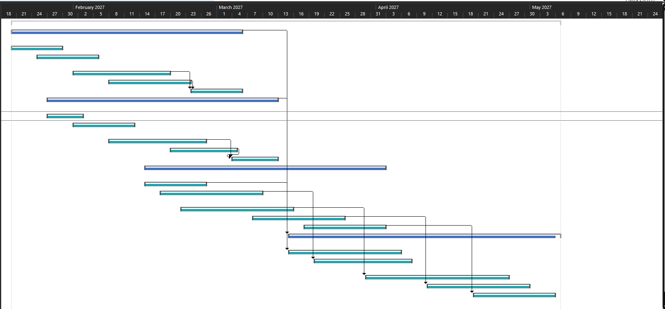

8. Scrum Backlog (Jira)
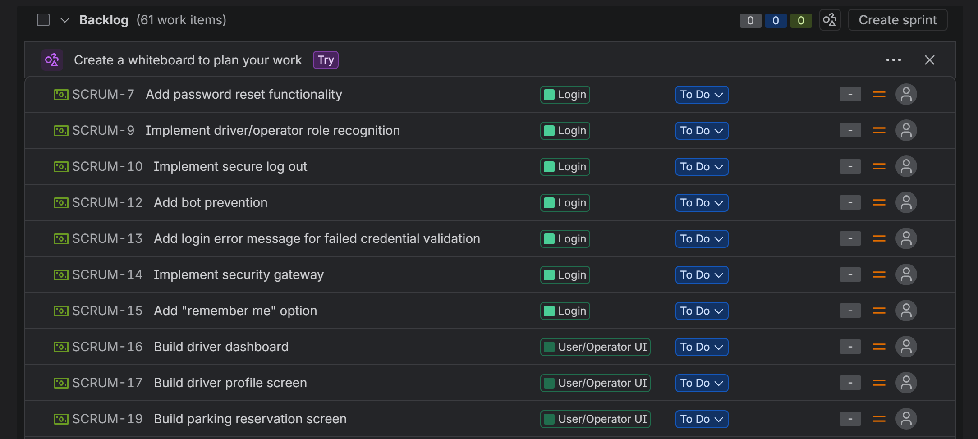
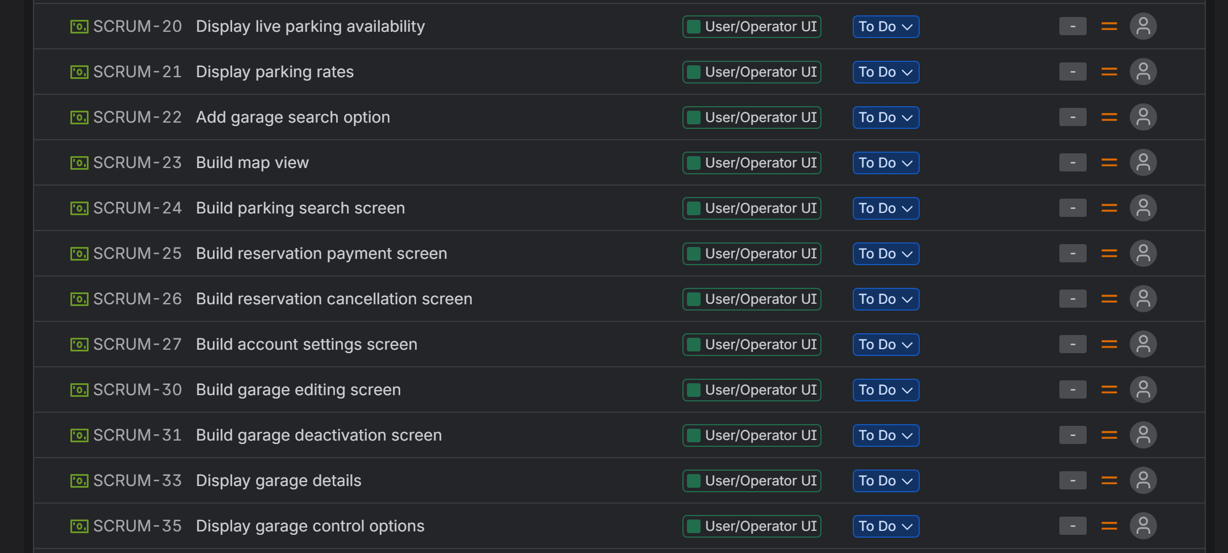
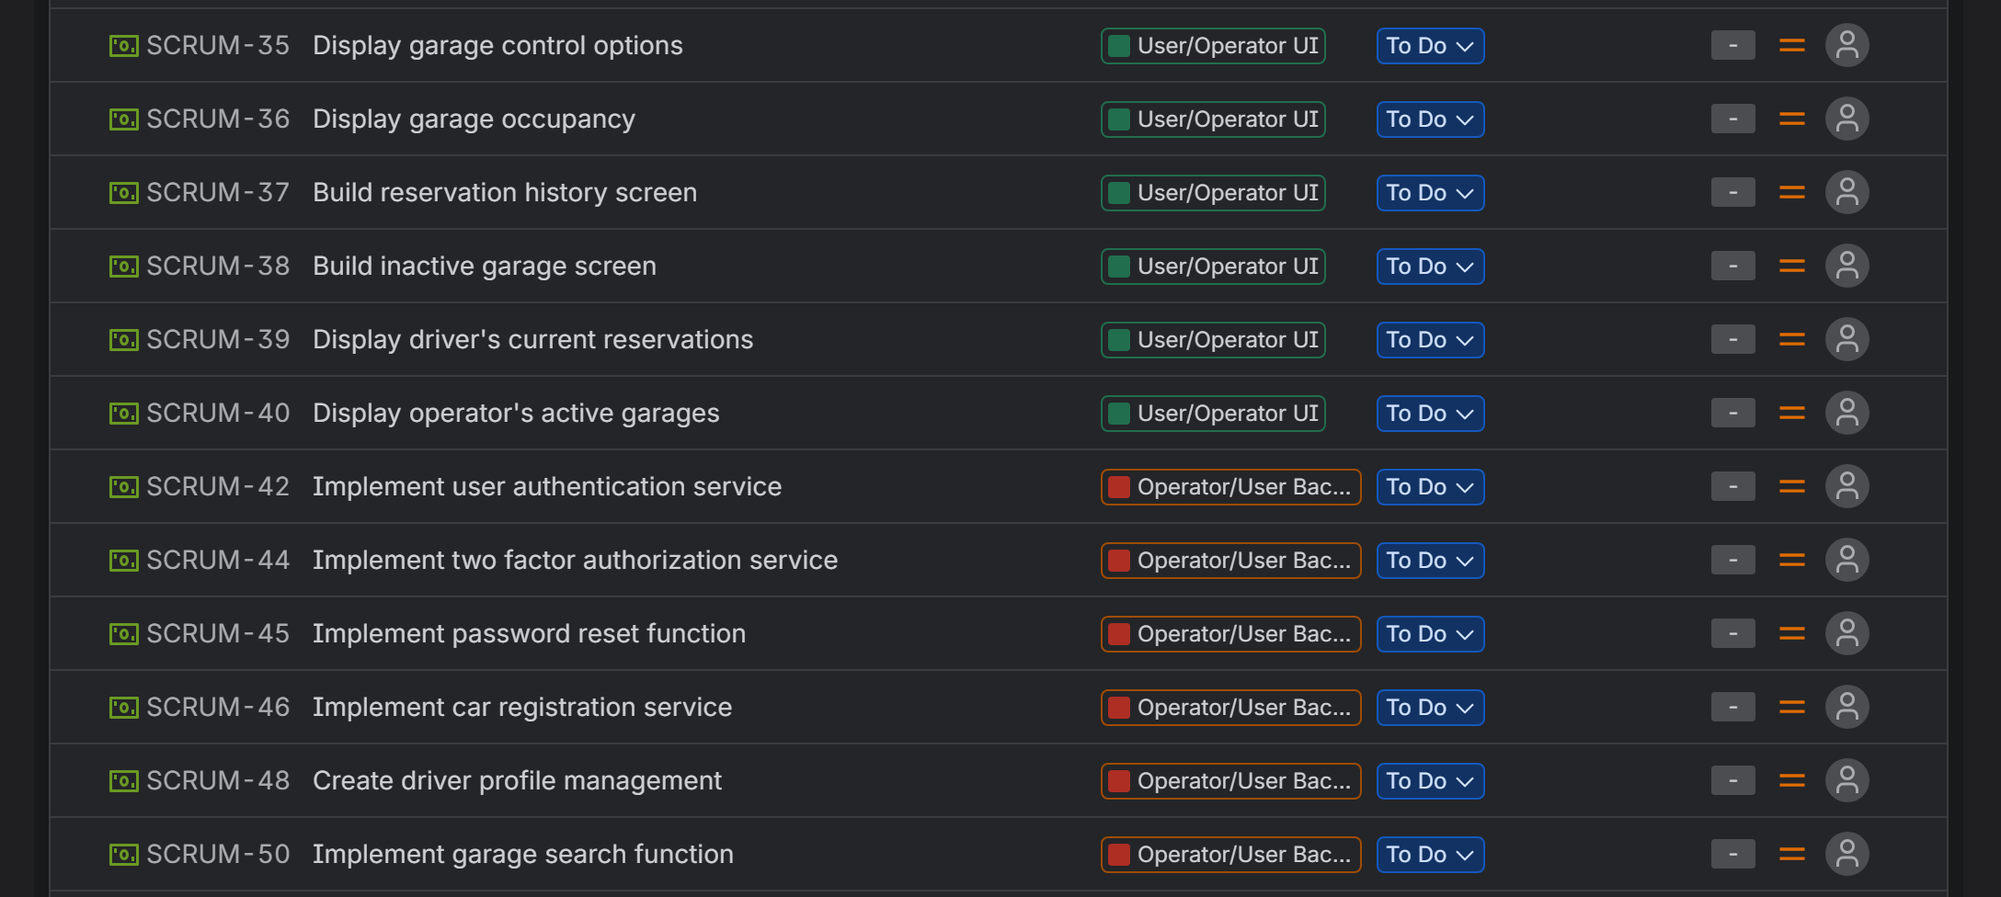
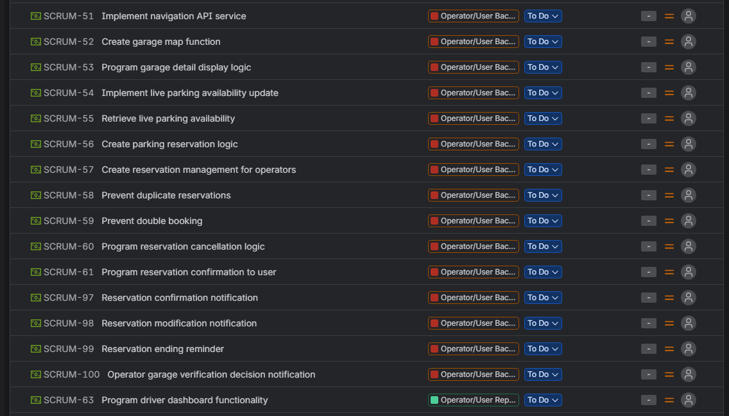
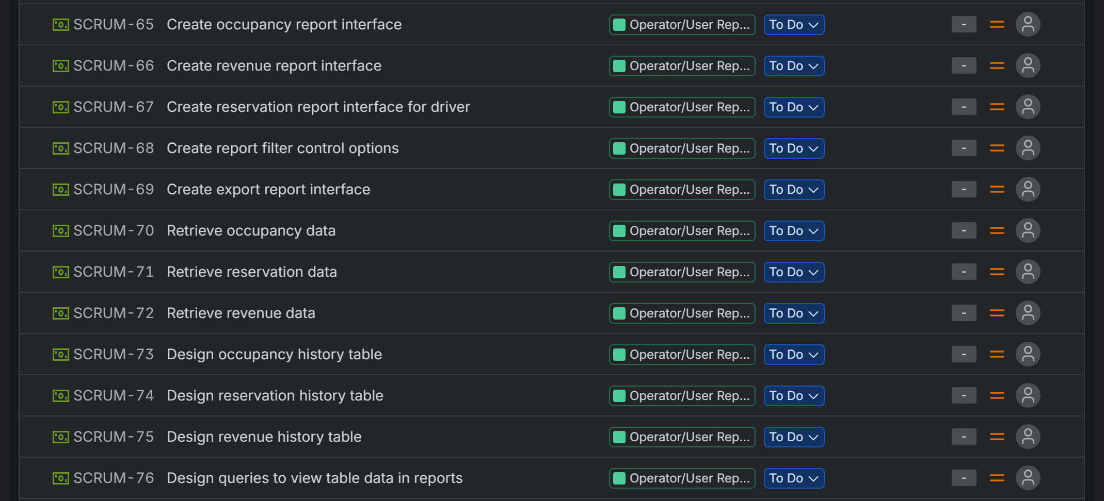
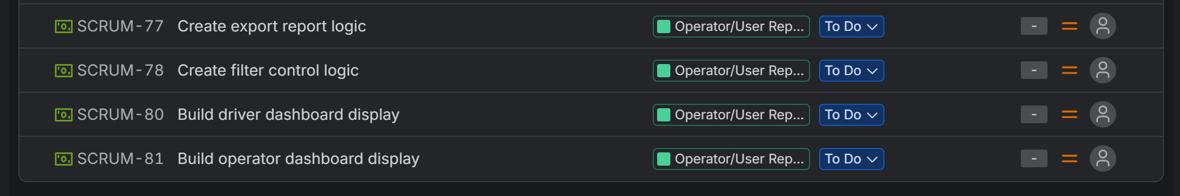
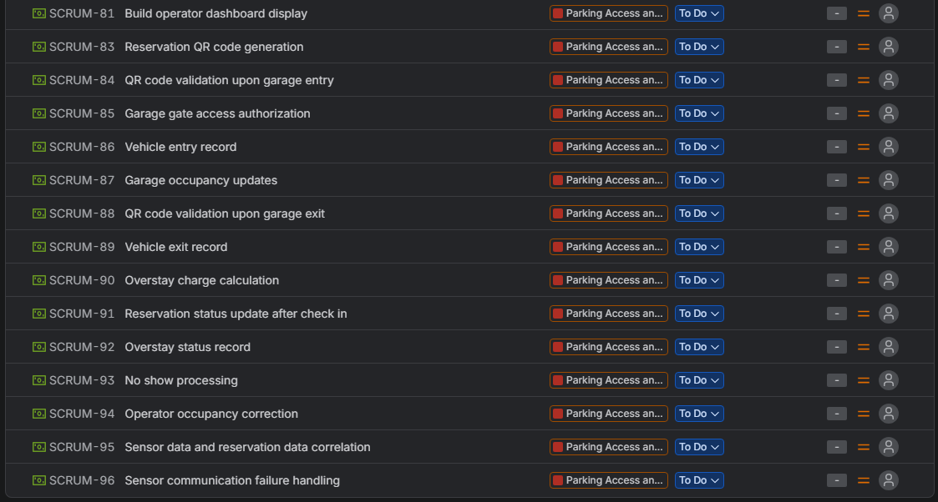

9. Scrum Sprint 1 Backlog (Jira)
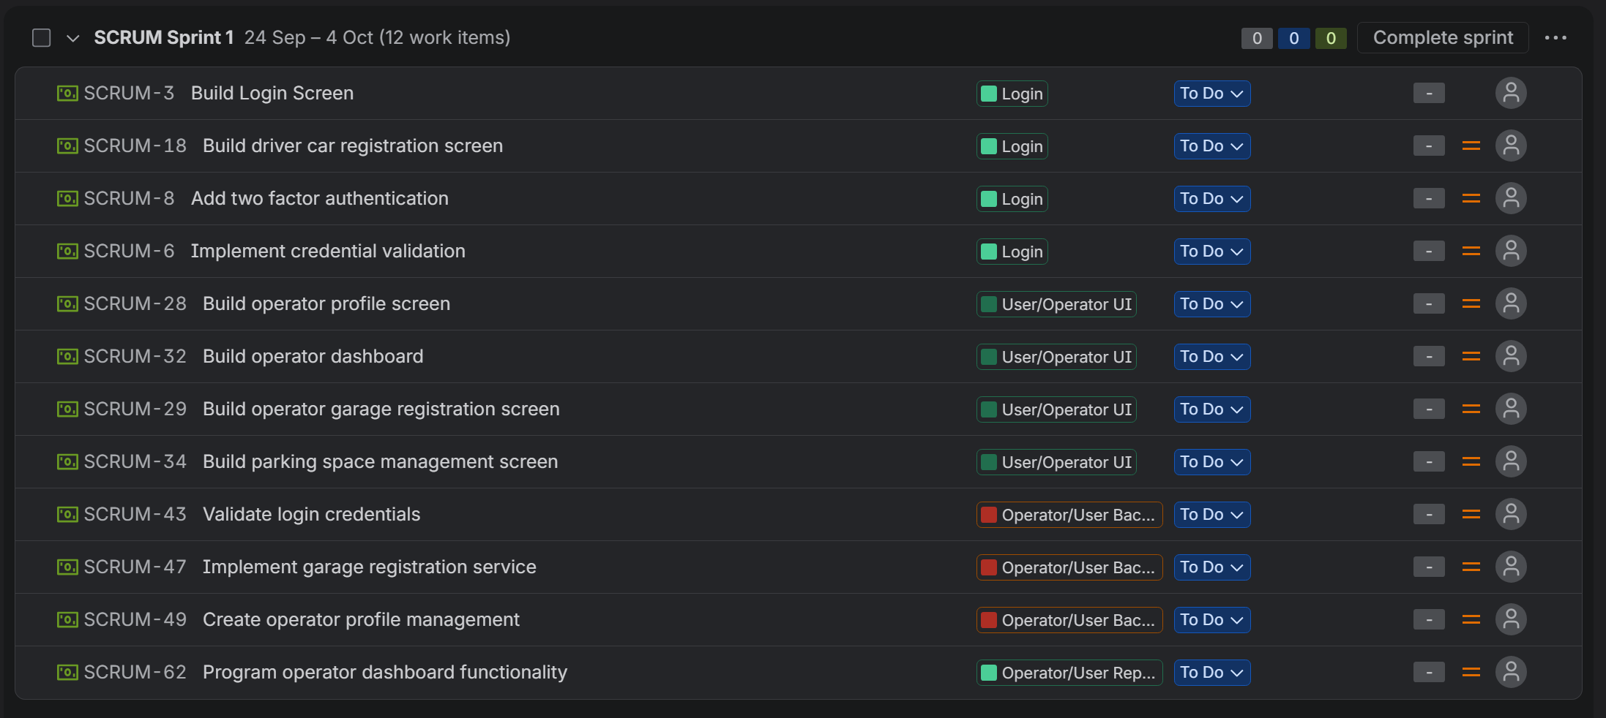

10. Risk Assessment
Technical Risks
- Design risks
- Mobile application compatibility
- Live update data synchronization failure
- Database storage issues
- API dependency failures
- Front End and Back-end integration failure
- Operational failure
- Hardware integration failure
Schedule Risks
- Natural disasters/power outages
- Dependency risks (APIs)
- Scheduling errors
- Scope creep
- Learning curve risks
Financial Risks
- Hidden costs
- Scope creep
- Hardware cost overruns
- Labor overruns
- Reworking
- Cloud hosting fees changing
- Cybersecurity breach cost
People Risks
- Temporary loss of members
- Permanent loss of members
- Member availability
- Skill gaps
- Understaffing
- Resistance to change
- Lack of clarity on roles and tasks
- Poor communication
- Conflict

Risk Register:
Risk ID | Risk Title | Description | Probability | Impact | Owner | Response strategy | Status | Category
R1 | Design Risks | Functionality of the application is comprised because users cannot access most of the functions | Medium | High | Front-End Team | Review what parts of the app are dysfunctional, revisit parts of interface that are damaged, remake or rework design | Open | Technical
R2 | Mobile Application Compatibility | The mobile app is unable to realize the full functionality of the app because the interfaces have not been properly adjusted for a mobile device | Medium | High | Front-End Team | Review what parts of the mobile app are dysfunctional, revisit parts of interface that are damaged, remake or rework design | Open | Technical
R3 | Live Update Synchronization failure | The application cannot sync live parking availability with the user interface so they can reserve parking | Medium | High | Back-End Team | Close garage, check synchronization, validate entry/exit data, test failure scenario | Open | Technical
R4 | Database storage issues | Database is not storing information | Medium | High | Database development team | Monitor database capacity, archive old data, scale storage if needed, alerts if no data is stored for 1 day | Open | Technical
R5 | API Dependency Failures | API services are not working | Medium | High | Back-End Team | Reach out to API service, use alternative APIs for critical third party services | Open | Technical
R6 | Front and back end integration | Front end is not integrating properly with back end, like buttons not working or going to the wrong page | Medium | Medium | Back-End Team and Front-End Team | Check logic and interface code, test integration early and regularly, resolve communication issues | Open | Technical
R7 | Operational Failure | Application does not operate properly | Medium | High | Back-End Team | Check application logic, check for bugs, isolate issues with testing, rework code till app functions | Open | Technical
R8 | Hardware integration failure | The hardware is not communication properly with the software | Medium | High | Devops | Check logic, find whether its hardware or software issue, use new hardware, try alternative hardware options | Open | Technical
R9 | Natural Disasters | Causes power outages, transportation issues, and threat to member safety | Low | High | Entire Team | Remain at home until further notice, possibly pass work to branch in unaffected areas | Open | Schedule
R10 | Dependency Risks | API services no longer work and the system needs to be reworked to accommodate new services | Low | High | Back-End Team | Identify and maintain alternative APIs | Open | Schedule
R11 | Scheduling errors | Not enough time was allocated to tasks that should have received more time | Medium | Medium | Project Manager | Reallocate time between tasks, extend deadlines, assign more members to smaller teams | Open | Schedule
R12 | Scope Creep | Satisfied customers ask for more features that we did not agree to | High | Medium | Project Manager | Try to avoid if possible, if not keep new features to a minimum and reasonable, form teams and schedule accordingly | Open | Schedule
R13 | Learning Curve Risks | New tools or industries require team to learn new skills, takes more time | High | Medium | Corresponding team | Reassign senior members to the lagging team and move junior members to easier tasks | Open | Schedule
R14 | Hidden costs | Costs that were not accounted for in the budget appear and cause budget overruns | Low | Medium-High | Project Manager | Try to avoid by budgeting effectively, if not, re-budget to account for new costs, maintain contingency budget | Open | Finance
R15 | Hardware cost overruns | Hardware costs increase beyond what was budgeted | Low | Medium | Project Manager/Team Lead | Secure hardware early, use contingency budget, check alternative hardware | Open | Finance
R16 | Labor Cost Overruns | Team overtime to complete the project requires more of the budget than expected | Low | High | Project Manager/Team Lead | Monitor labor hours against estimates, rebalance workloads, limit overtime, use contingency funds when needed | Open | Finance
R17 | Rework Costs | Technical issues may require completed work to be reworked or rebuilt, increasing labor and cost | High | Medium | Technical Lead | Validate requirements early, regular testing and review, handle issues as soon as they arise | Open | Finance
R18 | Cloud hosting fees changing | Cloud service provider changes their prices which affects our budget | Low | Medium | Project Manager/Cloud Infrastructure Lead | Monitor provider pricing, set budget alerts, compare alternative cloud service provider, maintain contingency reserve | Open | Finance
R19 | Cybersecurity breach risk | A cybersecurity breach into the system compromises the data and leads to recovery costs, service disruption, and financial losses | Low | High | Security Lead/ Technical Lead | Maintain strong cybersecurity measures, access controls, encryption, regular security testing, backups, and a documented incident-response plan | Open | Finance
R20 | Temporary Loss of Members | Members become sick, face family emergencies, or become injured and need time off | High | Medium | Team Lead | Cross-train team members, document tasks and roles, maintain shared project files, reassign critical tasks | Open | People
R21 | Permanent Loss of Members | Members may quit | Medium | High | Team Lead/Project Manager | Cross-train team members, maintain document tasks and roles, transfer tasks and roles, replace team member if necessary | Open | People
R22 | Member Availability | Members have restrictions on how many hours they can work, limiting overtime when needed | Medium | Medium | Team Lead | Maintain member schedules, identify member availability early, assign back up resources for critical tasks, adjust workloads or deadlines when needed | Open | People
R23 | Skill Gaps | Members don't have the skills needed to complete a certain tasks or need to learn it | High | Low | Team Lead | Monitor progress and any tasks falling behind, reassign tasks if needed, provide training resources, have junior members work with senior members | Open | People
R24 | Understaffing | Not enough members were allocated to a team/critical task | Low | Medium | Project Manager | Prioritize critical work, redistribute roles and responsibilities, request additional resources if needed | Open | People
R25 | Resistance to Change | Team does not want to change how they handle new tasks | Medium | Low | Team Lead | Provide training and support, clarity of benefit of new methods, address concerns during implementation | Open | People
R26 | Lack of Clarity | Team members don't fully understand roles and responsibilities | High | Low | Team Lead | Hold consistent team meetings, maintain and update role sheet, follow sprint backlogs tasks | Open | People
R27 | Poor Communication | Project team is not communicating, leading to stalling and misaligned tasks | High | Medium | Team Lead | Maintain communication plan, clear communication channels, regular team meetings, document key decisions | Open | People
11. Communication Plan
Communication/Meeting | Participants | Purpose | Frequency/Cadence | Method/Tool | Owner | Reporting/Documentation
Project Team Meeting | Entire Project Team | Review project progress, upcoming deadlines, risks, and updates | Weekly | Microsoft Teams/In-person | Project Manager | Meeting notes and action items
Back-End Development Meeting | Back-end developers | Review logic, APIs, authentication, occupancy and payment development | 2x per week | Microsoft Teams | Back-end lead | Jira Updates
Front-End Development Meeting | Front-end developers | Review UI development | 2x per week | Microsoft Teams | Front-end lead | Jira updates
Database meeting | Database developers | Review database design | 2x per week | Microsoft Teams | Database Development lead | Database design notes, Jira
Integration and Testing Meeting | Developers and testing team | Review integration, defects, and test results | Weekly, more often during testing phase | Microsoft teams | Testing Lead | Defect log, Jira
Back-End Development Stand Up | Back-end developers | Go over what has been done, what will be done today, and blockers | Daily, 15 minutes | In-person | Back-end Scrum Leader | Notes
Front-End Development Stand Up | Front-end developers | Go over what has been done, what will be done today, and blockers | Daily, 15 minutes | In-person | Front-end Scrum Leader | Notes
Database meeting | Database developers | Go over what has been done, what will be done today, and blockers | Daily, 15 minutes | In-person | Database Scrum Leader | Notes
Integration and Testing Meeting | Developers and testing team | Go over what has been done, what will be done today, and blockers | Daily, 15 minutes | In-person | Testing Scrum Leader | Notes
Sprint Planning | Development team | Select and prioritize tasks from sprint backlog | Beginning of each sprint | Jira, Microsoft Teams | Scrum Lead | Sprint Backlog
Sprint Review | Project team, stakeholders | Review completed work during last sprint | End of each sprint | Jira, Microsoft Teams | Project Manager | Sprint review notes, Jira
Risk Review | Project manager, team leads | Review possible risks and response strategies | Weekly | Microsoft Teams | Project Manager | Gantt chart updates
Stakeholder Status Report | Project manager, stakeholders | Go over progress, updates, and future plans | Weekly | Microsoft Teams | Project Manager | Software Requirements Specifications document

12. Role Sheet
Role | Name | Skill Level | % Allocation
Project Manager | Ahmed Mahmoud | Mid-level | 30%
Back-End Developer | Bill Dean | Senior | 45%
Back-End Developer | John Phelps | Mid-level | 55%
Back-End Developer | Jeffery Jenkins | Junior | 75%
Quality Assurance | Quill Quagmire | Mid-level | 40%
Quality Assurance | Quincy Donald | Junior | 50%
UX Developer | Oswald Orkin | Senior | 70%
UX Developer | Tony Pierre | Junior | 85%
Devops | David Dietre | Mid-level | 75%
Devops | Anh Nguyen | Mid-level | 75%
Business Analyst | Jose Martinez | Mid-level | 60%
Subject Matter Expert | Maya Anabelle | Mid-level | 60%
Product Owner | Percy Phillips | Senior | 15%

13. Resource Plan
Role | Name | Skill Level | Estimated Hours | Hourly Rate | Cost
Project Manager | Ahmed Mahmoud | Mid-level | 204 | $ 40 | $ 8,160
Back-End Developer | Bill Dean | Senior | 306 | $ 60 | $ 18,360
Back-End Developer | John Phelps | Mid-level | 374 | $ 50 | $ 18,700
Back-End Developer | Jeffery Jenkins | Junior | 510 | $ 40 | $ 20,400
Quality Assurance | Quill Quagmire | Mid-level | 272 | $ 35 | $ 9,520
Quality Assurance | Quincy Donald | Junior | 340 | $ 30 | $ 10,200
Front-End/UX Developer | Oswald Orkin | Senior | 476 | $ 45 | $ 21,420
Front-End/UX Developer | Tony Pierre | Junior | 578 | $ 40 | $ 23,120
Devops | David Dietre | Mid-level | 510 | $ 60 | $ 30,600
Devops | Anh Nguyen | Mid-level | 510 | $ 60 | $ 30,600
Business Analyst | Jose Martinez | Mid-level | 408 | $ 50 | $ 20,400
Subject Matter Expert | Maya Anabelle | Mid-level | 408 | $ 60 | $ 24,480
Product Owner | Percy Phillips | Senior | 102 | n/a | n/a
 |  | TOTAL: | 4998 |  | $ 235,960

14. Cost Plan
Item | Category | Qty/Months | Unit Cost | Duration (months) | Total | Notes
Team Labor | Labor | 1645 hours | $48/hour average | 4 | $ 235,960 | Includes project management, development, QA, and DevOps
Software Licenses | Tools | Once | $ 600 | N/A | $ 600 | Developing, recording, and planning tools
Security | Infrastructure | 250/month | $ 250 | 4 | $ 1,000 | Cybersecurity, data safety, encryption
Cloud Hosting | Infrastructure | 300/month | $ 300 | 4 | $ 1,200 | Application hosting, database hosting, storage, backups
APIs | 3rd Party Services | 300/month | $ 300 | 4 | $ 1,200 | Payments, navigation and map
Integration/Test Hardware | Hardware | Once | $ 1,200 | N/A | $ 1,200 | QR code scanners and entry/exit sensor integration
Contingency Reserve | Reserve | Once | Applied to total | N/A | $ 36,174 | 15% contingency
 |  |  |  | Total: | $ 241,160
 |  |  |  | Total w/ Contingency | $ 277,334

15. RACI Matrix
Task/Role | Project Manager | Back-End Developer | Quality Assurance | Front-End/UX Developer | DevOps | Business Analyst | Subject Matter Expert | Product Owner
Project Planning | R/A | I | I | I | I | I | I | I
Requirement Definition | C | C | C | C | I | R | C | A
Database Development | I | R/A | C | I | C | C | I | I
Back-End Development | I | R/A | C | C | C | C | I | I
Front-End Development | I | C | C | R/A | C | C | C | I
API Integration | I | R | C | C | A | C | C | I
System Integration | A | C | C | C | R | C | C | I
Hardware integration | A | C | C | I | R | C | C | I
Security | A | R | C | I | I | I | I | I
Quality Assurance | I | C | R/A | C | I | I | C | I
Deployment | A | C | C | I | R | I | C | I
Risk Management | R/A | C | C | C | C | C | C | I

16. Stakeholder Matrix
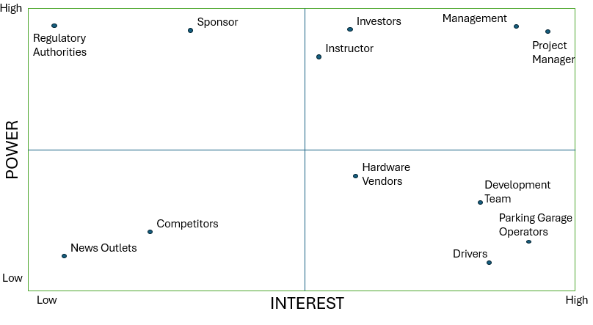

17. Project Charter
Project Charter
Project Name:  Parking Application | Project Manager:  Ahmed Mahmoud | Sponsor:  Otto Dobretsberger | Date:  10/29/2026
Business Need: We want to create a parking application with live, automated parking availability data along with parking details beyond just availability such as safety. There are not many applications that provide a platform that combines a detailed description of parking garages while also providing live parking availability that does not require manual entry by staff. Our app should facilitate drivers finding parking garages wherever they are and facilitate operators advertising and managing their parking garages.
Scope:  - Mobile/web application development  - Live occupancy monitoring  - Entry and exit sensor integration  - Parking garage management  - Payment and reporting |  | Goals: Functional parking application  - Web/mobile platform  - Hardware integration  - Live parking updates  - Reservation/payment system  - Garage monitoring
Budget:  - Labor: $235,960  - Software & Tools: $600  - Infrastructure, Security & APIs: $3,400  - Hardware: $1,200  - Contingency (15%): $36,174  Total Budget: $277,334 |  | Risks:  - Live occupancy update failures  - Hardware and sensor integration issues  - Database and data storage failures  - Cybersecurity breaches  - Technical rework/ schedule overruns  - Poor team communication
Timeline:
Phase | Date
Project Start | 1/20/2027
Back-End Development | 1/20/2027 - 3/5/2027
Database Development | 1/27/2027 - 3/12/2027
Front-End Development | 2/15/2027 - 4/2/2027
Integration and Testing | 3/15/2027 - 5/6/2027
Project Completion | 5/10/2027

The Team
Roles | Responsibility
Project Manager | Manage scope, schedule, budgets, risks, communication and overall project coordination
Back-End Developer | Develop business logic, APIs, reservations, payments, occupancy, and system processing
Front-End/UX Developer | Designs and develops driver and operator interfaces for usability and accessibility
Quality Assurance | Tests system functionality, integrations, performance, and defects to ensure quality.
DevOps/Integration | Manages deployment, cloud environments, system integrations, and hardware connectivity.
Business Analyst | Defines requirements, analyzes business needs, and ensures solutions align with stakeholder expectations.
Subject Matter Expert | Provides parking-industry knowledge and validates that system features support real-world operations.

18. Team Charter
